Survey Questionnaire Module Design Framework

Executive summary
For a generic, domain-agnostic questionnaire, the safest default is to use closed, item-specific questions for most modules, and to reserve open-ended text for optional reflection or clarification only. Yes/no items work best as gates for eligibility, routing and simple factual checks; multiple choice is usually best for profile and behavioural reporting; balanced 5- or 7-point rating scales are best for attitudes and satisfaction; ranking should be used sparingly and only after shortlisting; and sliders should usually be limited to single, salient continuous judgements such as current emotional intensity, not used as a wholesale replacement for ordinary scales. That direction is consistent with AAPOR guidance on burden, balance and response-option design, with Krosnick’s survey-methodology synthesis on open versus closed questions and scale design, with evidence favouring item-specific over agree/disagree response options, and with comparative evidence showing that sliders usually do not materially improve data quality over radio-button scales. [1]
Question fatigue is mostly a problem of cognitive load, repetitiveness, emotional toll and unnecessary branching complexity, not just raw question count. Good design therefore means short questions, similar topics grouped together, general questions before specific ones, sensitive questions later unless needed for safety, optional skip routes for difficult items, and a hard discipline about session length. AAPOR explicitly recommends keeping questionnaires and individual questions short, limiting difficult, sensitive and open-ended items, and allowing skipping for difficult or sensitive questions; Pew caps ordinary online panel instruments at about 15 minutes and uses weighted “question points” rather than crude counts; Krosnick’s work explains why fatigue and task difficulty increase satisficing and degrade answer quality. [2]
For emotional intensity, a practical generic framework is a brief non-diagnostic check-in, built around a 0–10 intensity item modelled on the Distress Thermometer, plus a second item on how hard it is to continue, plus a binary “safe to continue” gate for sensitive modules. The clinical literature around the Distress Thermometer commonly treats 4+ as a level that merits further evaluation or discussion, while oncology guidance also shows that higher thresholds such as 7+ can be useful in narrower contexts such as depression screening; these are useful reference points for survey UX thresholds, though not as stand-alone diagnoses. If a survey enters self-harm or suicide territory, generic intensity checks are not enough: use a validated pathway such as ASQ or C-SSRS and an escalation plan such as SAFE-T. [3]
For safety and privacy, the essentials are blunt: disclose sensitive topics before they appear, let respondents skip or stop at any time, separate structural skips from respondent skips in the data, do not collect more personal data than is necessary, shorten retention for raw free text and high-risk fields, and de-identify or destroy material once it is no longer needed. WHO and NHMRC both emphasise distress protocols and voluntary participation, AAPOR recommends advance disclosure and support resources for sensitive topics, and GDPR/UK GDPR plus the Australian Privacy Principles require data minimisation, storage limitation and stronger care around sensitive information. [4]
The sections below give proposed defaults for a generic questionnaire. Where the literature gives principles but not one fixed universal number—especially for exact module question caps, pause copy and memory-field naming—this report states that explicitly and provides operational heuristics rather than pretending there is a single canonical rule. [5]

Evidence base and assumptions
This framework prioritises primary and quasi-primary guidance from AAPOR, WHO, CDC, NHMRC, NCI, NIMH, SAMHSA, the EDPB, ICO and OAIC, then uses classic survey-methodology literature where official guidance is silent—especially Krosnick on questionnaire design and Saris et al. on response-format quality. The aim is not to overfit for one sector such as health, HR, education or market research, but to produce a conservative default that is robust across ordinary self-administered online surveys and adaptable to interviewer-administered modes where necessary. [6]
Two assumptions matter. First, because no population, mode or legal jurisdiction was specified, the defaults below assume a generic online, self-paced, adult-facing instrument, with notes where interviewer administration or highly sensitive modules change the recommendation. Second, for Australia specifically, the NHMRC National Statement 2023 remains the current baseline at the time of writing, while NHMRC says the 2025 revision’s effective date is still delayed and estimated for May or June 2026. [7]
APA’s ethics baseline points in the same direction: informed consent can only be dispensed with in tightly limited low-risk cases, and psychologists are expected to take reasonable steps to avoid harming research participants. That is consistent with the broader line taken here: if questions can reasonably cause distress, do not treat them like ordinary neutral content. [8]

Decision table for survey modules
The table below is a recommended decision table, not a legal rulebook. “Default” means the recommended starting point for a generic module. “Hard cap” means the limit above which a different design should usually be chosen.
Module | Primary purpose | Recommended question types | Default anchors or controls | Ranking limit | Slider range | Rationale
Consent and privacy | Participation, consent, data-use choices | Yes/no; single-select multiple choice | “Yes, I consent / No, I do not consent”; separate opt-ins for sensitive processing, contact, and secondary use; no bundled consent | None | Avoid | Consent works best when explicit, unambiguous and separated by purpose. EDPB guidance allows broad or dynamic consent in research but still requires lawful processing, transparency and safeguards; OAIC likewise stresses express consent for sensitive information. [9]
Eligibility and routing | Early filter and branching gate | Yes/no; single-select multiple choice | “Yes / No / Unsure” only if uncertainty is genuinely meaningful | None | Avoid | Early binary or single-select filters reduce burden and keep respondents out of irrelevant paths. Clear skip instructions are important, and electronic routing is preferable where branching is non-trivial. [10]
Profile and factual background | Stable attributes, demographics, non-emotional facts | Single-select and multi-select multiple choice; optional “Other, specify” | Response sets should be exhaustive, mutually exclusive where appropriate, and include “Prefer not to say” for sensitive fields | None | Usually avoid | Closed categories reduce burden and coding effort, but sensitive profile items need a refusal option and careful privacy handling because they can be identifying on their own or in combination. [11]
Behaviours, experiences and frequencies | Events, habits, occurrence or recency | Yes/no gate plus item-specific frequency scale or categorical multiple choice | Prefer item-specific anchors such as “Never / Rarely / Sometimes / Often / Always” or bounded recency categories; avoid generic agree/disagree | None | Optional only for one salient quantity | Item-specific response options generally outperform agree/disagree formats, and binary gates stop unnecessary follow-ups. For frequency, bounded categories are easier to answer than vague prose and easier to analyse than free text. [12]
Attitudes, satisfaction and perceived quality | Evaluations and opinions | 5- or 7-point rating scales; single-select multiple choice; optional short open follow-up | Use balanced item-specific anchors; include a midpoint if genuine neutrality is plausible | If absolutely needed, rank only top 3 after rating | If used, 0–10 integer only | AAPOR recommends balanced, logical response options; Krosnick’s synthesis supports moderately long balanced scales and cautions against removing real neutral options; item-specific anchors beat agree/disagree in quality. Sliders do not usually improve quality enough to justify replacing ordinary scales. [13]
Priorities and trade-offs | Comparative preference among options | Shortlist via multiple choice, then partial ranking | “Choose your top 3” then rank those only | Default: top 3. Hard cap: 5 ranked items. If list >7, shortlist first | Avoid | Ranking is cognitively effortful, and long ranking lists are a known burden. A practical default is partial ranking rather than full ordering of many items. [14]
Emotional intensity check-in | Real-time burden, distress and continuation readiness | Single-item rating scale or simple slider; yes/no safety gate | Intensity: 0 “none/calm” to 10 “overwhelming”; continuation impact: 0 “easy to continue” to 10 “impossible to continue”; plus “Do you feel safe to continue right now?” | None | Preferred: 0–10 integer | The Distress Thermometer is brief and widely used on a 0–10 scale; a second “impact/continuation” item improves specificity conceptually in the same spirit as the Impact Thermometer literature. A binary safety gate prevents false reassurance from a single numeric score. [15]
Sensitive risk and safety | Trauma, abuse, self-harm, discrimination, substance use, acute welfare concerns | Yes/no gate; broad-category multiple choice; validated screener where applicable; optional open text off by default | Show a content note immediately before entry; include “Prefer not to answer”; keep wording broad unless validated clinical screening is required | None | Usually avoid; 0–10 only if paired with escalation logic | WHO and AAPOR both treat these as higher-risk domains requiring explicit warnings, skip rights and support planning. If suicidality or self-harm is in scope, use validated tools such as ASQ or C-SSRS and a response pathway such as SAFE-T rather than ad hoc detail probing. [16]
Reflection and narrative follow-up | Nuance, explanation, “anything else” | Optional open-ended text only | One prompt at a time; soft word cap or time expectation; always skippable | None | None | Open text is valuable for nuance but it is the highest-burden format, most likely to be skipped, and the riskiest for privacy leakage and third-party identifiers. Keep it late, rare and optional. [17]
A useful design corollary is this: rate first, rank second, narrate last. That ordering captures broad coverage with relatively low burden, then asks respondents to do harder comparative or narrative work only when it is analytically necessary. [18]

Design rules, limits and pacing
The wording rules are not exotic. Ask one concept at a time. Avoid double negatives, double-barrelled stems and leading authority cues. Use simple language, define terms that respondents may interpret differently, and choose balanced response sets that make both sides of the answer space visibly legitimate. AAPOR explicitly warns about double negatives, double-barrelled yes/no items, leading wording and question-order effects; it also recommends short, simple, unbiased questions with logical response options. Where possible, prefer item-specific scales over generic agree/disagree formats because the latter are more vulnerable to acquiescence and lower measurement quality. [19]
Order matters. Start with easy, non-personal, high-value items; place important questions early enough that you still capture them if respondents drop out; group similar topics together; and, within a topic, go general before specific unless there is a clear safety reason to screen first. Sensitive questions usually belong later, after rapport has been built, but not so late that respondents are already exhausted. Where non-ordinal response options are shown visually, rotation or randomisation should be considered to reduce order effects; by contrast, ordered rating scales should preserve a sensible progression. [20]
Fatigue mitigation should be operational, not rhetorical. Avoid long matrices, long ranking exercises, repeated open-ended prompts, heavy scrolling and multi-layer branching that respondents have to infer for themselves. Use electronic routing where feasible. Show progress by module rather than by dozens of tiny pages. Insert an emotional/burden pulse after heavy sections, and if burden rises, shorten the remainder by dropping optional open text and replacing ranking with a simpler “pick your top 1–3” path. Sliders can be engaging, but the evidence does not justify using them everywhere, and they should be used sparingly because graphic complexity can increase break-offs. [21]

Module limits and pacing
In practice, displayed questions after branching matter more than total authored questions. The table below gives proposed defaults for a generic online survey.
Module | Minimum shown | Recommended default shown | Maximum shown in one session | Recommended pacing | Basis
Consent and privacy | 2 | 3 | 5 | 30–60 seconds | Keep consent explicit and brief; do not bury secondary-use choices later. [22]
Eligibility and routing | 2 | 3–4 | 6 | 30–90 seconds | Early gating reduces irrelevant burden. [23]
Profile and factual background | 3 | 5–6 | 8 | 1–2 minutes | Closed formats are lower burden and easier to code. [24]
Behaviours and experiences | 3 | 5–8 | 10 | 1.5–3 minutes | Use yes/no gates plus item-specific follow-ups. [25]
Attitudes and satisfaction | 3 | 5–8 | 12 | 2–4 minutes | Moderately long balanced scales are usually fine; do not over-battery. [26]
Priorities and ranking | 1 task | 1 task | 2 tasks | 45–90 seconds per task | Ranking is effortful; do not ask for full ordering of long lists. [14]
Emotional intensity or burden pulse | 1 | 1–2 | 3 | 15–30 seconds each | Brief check-ins are enough if you use them consistently at entry, midpoint or after heavy modules. [15]
Sensitive risk and safety | 0 unless triggered | 2–4 | 6 | 1–3 minutes, with pre- and post-pause offer | Keep to the minimum necessary detail and pair with distress protocol. [27]
Open reflection | 0 | 1 | 2 | 30–90 seconds each | Open text is time-consuming and more often skipped. [28]
Whole session | 12 | 18–25 | 35 displayed items, or about 15 minutes hard cap | Default: 6–10 minutes. Hard cap: 15 minutes for generic online self-administered sessions | AAPOR stresses low burden; Pew caps ordinary online surveys at 15 minutes and uses weighted timings because open-ended items take much longer than ordinary closed questions. [29]
A crude raw count is still inferior to a weighted pacing budget. A practical default is to budget approximate effort as follows: stand-alone ordinary closed item = 1 unit; battery item = 0.67; simple slider or rating = 1; check-all-that-apply = 2; short ranking task = 3–4; short open text = 5; explanatory open text = 8. That mirrors Pew’s timing logic for ordinary, battery and open-ended items, while extending it conservatively to ranking and other burden-heavy tasks. Aim for 60–70 weighted units for a comfortable generic session and treat 85 units as a hard cap. The exact weights for ranking and special safety prompts are proposed heuristics rather than settled standards. [30]

Emotional intensity, skip, pause and branching

Emotional intensity measurement framework
This framework is designed to measure current survey-induced or topic-related emotional activation, not to diagnose a mental disorder. It should be used as a routing and respondent-protection tool.
Component | Definition | Sample item | Anchors | Scoring use
Intensity | Current subjective emotional intensity | “Right now, how emotionally intense does this topic feel?” | 0 = none/calm; 10 = overwhelming | Primary burden signal
Continuation impact | How hard continued participation would feel | “How hard would it be to continue right now?” | 0 = easy to continue; 10 = impossible to continue | Distinguishes “strong feeling” from “cannot keep going”
Safety to continue | Immediate self-assessed readiness | “Do you feel safe to continue right now?” | Yes / No | Overrides numeric score when “No”
Optional trend check | Change from baseline or prior module | “Compared with the start of the survey, do you feel less intense, about the same, or more intense?” | Less / Same / More | Useful for repeated-module monitoring
Recommended score handling. Use Intensity as the lead indicator, Continuation impact as the operational modifier, and Safety to continue as the hard stop gate. A simple composite can be calculated as round((Intensity + Continuation impact) / 2), but if Safety to continue = No, treat that as a high-priority stop condition regardless of the composite. This is deliberately simple because brief tools work best when respondents do not have to decode them. The underlying logic is consistent with the Distress Thermometer literature, where a single 0–10 distress item is used for fast triage and higher scores prompt further evaluation, not stand-alone diagnosis. [15]
Operational thresholds. For a generic survey UX, use these provisional cut-offs: 0–3 low = continue normally; 4–6 moderate = show a supportive non-alarmist reminder that skipping and pausing are available; 7–8 high = auto-offer pause before the next sensitive item and shorten the remaining path; 9–10 acute, or Safety to continue = No, = stop the sensitive branch and show a support exit or escalation route. The choice of 4+ as a “do something” boundary is grounded in the Distress Thermometer literature, while 7+ is a sensible upper operational threshold because oncology guidance shows that scores in that range are often used as a trigger for more thorough evaluation in narrower contexts. These are survey-protection thresholds, not clinical diagnoses. [15]
If the survey includes self-harm or suicide content, replace or supplement the generic intensity check with a validated protocol such as ASQ or C-SSRS, and define the post-response workflow in advance using a framework such as SAFE-T. A generic “intensity = 9” score is not enough on its own to manage suicide risk. [31]

Skip, pause and branch rules
The safest default is: respondents may refuse any question, skip any sensitive item, pause any time, and stop without penalty. WHO survey manuals state this directly, and AAPOR recommends skip options or explicit “don’t know / don’t want to answer” routes, especially for difficult or sensitive items. NHMRC also expects clear protocols for distress arising during data collection. [32]
Use these explicit rules:
Skip rules. Force answers only for the absolute minimum operational fields, usually participation consent and one or two routing gates. Sensitive items, open-ended prompts and difficult recall questions should remain skippable. Code structural skip, respondent skip, prefer not to answer, and don’t know separately; AAPOR explicitly says no-response must not be collapsed into substantive answer categories. [33]
Pause rules. Offer a manual pause at any point and an automatic pause after a sensitive module, after sustained inactivity, or when the emotional-intensity rule reaches the high band. Save progress automatically and return the respondent to a neutral holding screen, not back into the same distressing item. NHMRC’s emphasis on distress protocols and SAMHSA’s trauma-informed principles both support this respondent-control approach. [34]
Branch rules. Keep branching shallow and transparent: one clear gate, then one relevant follow-up block. WHO’s SHAPE questionnaire notes that skip logic can become hard to follow even for trained interviewers and recommends electronic data capture where feasible; the CDC and Australian BETA guide both recommend reviewing flow and logic in testing before launch. [35]
Compression rules when burden rises. If a respondent records moderate to high intensity, skips multiple sensitive questions, or times out on ranking/open-ended tasks, shorten the rest of the path: remove optional open text, replace ranking with “pick up to 3”, and move straight to debrief or closing questions. That follows directly from the burden evidence: reduce task difficulty and preserve answer quality. [36]
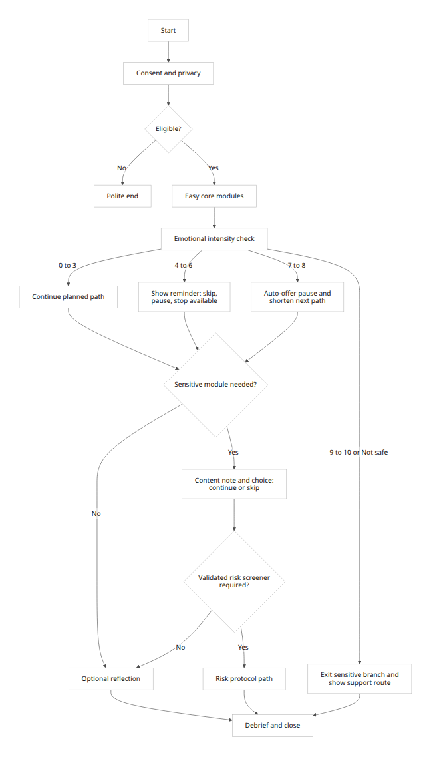
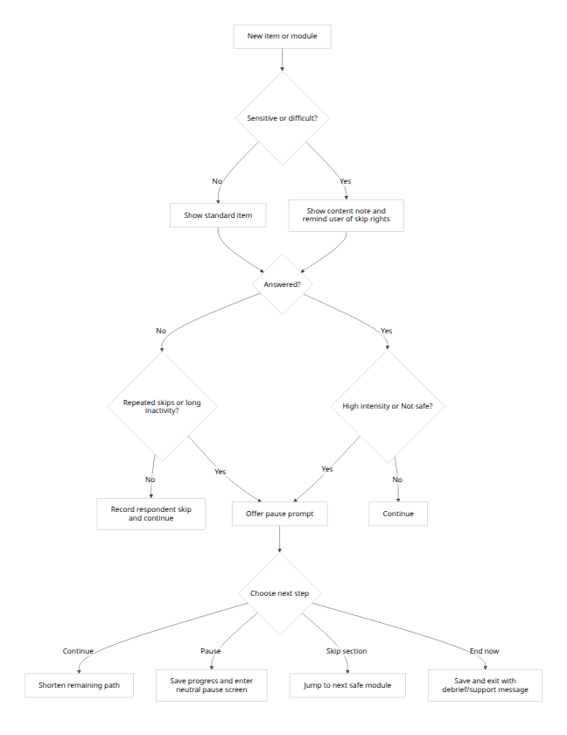

Suggested pause and warning prompts
Use short, neutral, non-coercive copy. For example:
Before a sensitive module
“The next section asks about experiences that some people find upsetting. You can skip any question, take a break, or finish now. Would you like to continue?”
Moderate-intensity pause offer
“You’ve answered several heavier questions. Your responses are saved. Would you like a short pause, to skip this section, or to continue?”
High-intensity auto-pause
“It looks like this section may be difficult right now. We can pause here, skip these questions, or finish for now.”
Safety exit
“Thanks for letting us know. We’ll stop the sensitive questions here. If you need immediate support, please use your local emergency or crisis services now.”
Those prompts operationalise AAPOR’s guidance to disclose sensitive topics before they appear and to allow skipping, WHO’s insistence on voluntary participation, and trauma-informed principles of safety, transparency, choice and avoiding retraumatisation. [37]

Safety warnings, unsafe rewrites and memory mapping

Unsafe or high-risk questions with safer rewrites
The table below focuses on question patterns that are unsafe because they are overly graphic, coercive, blame-laden, diagnostically sloppy, privacy-invasive, or likely to provoke unnecessary distress without analytical gain.
Unsafe or high-risk prompt | Main problem | Safer rewrite | Trigger warning or guardrail
“Describe exactly how you would kill yourself.” | Graphic method elicitation without a validated risk pathway | “Are you having thoughts of harming yourself right now?” If yes, route immediately to a validated self-harm pathway or crisis protocol | Content note: self-harm and suicide. Show support options before entry
“Why didn’t you leave/report the abuse?” | Victim-blaming and retraumatising | “Have you experienced physical, sexual, emotional or financial harm from another person?” Follow with optional broad categories only | Content note: violence or abuse. Remind respondent they do not need to give details
“Tell us the worst thing that happened during the assault.” | Graphic detail adds burden and often little extra analytic value | “If you want, you can tell us whether an unwanted sexual experience happened, without describing it in detail” | Content note: sexual violence. Offer skip and pause before and after
“List every illegal drug you used last week.” | Overly granular, potentially incriminating, high recall burden | “In the past 30 days, how often have you used non-prescribed substances?” Use bounded categories or professional-diagnosis wording where appropriate | Content note: alcohol or other drugs. State confidentiality limits clearly
“What is the lowest weight you reached and how did you get there?” | Can be triggering, competitive and clinically unsafe in generic surveys | “Have eating, weight or body-image concerns affected your wellbeing recently?” Add broad frequency or impact categories only | Content note: eating and body-image concerns
“Name the person who assaulted you / offended against you.” | Unnecessary third-party identifiers and legal/privacy risk | “Please do not include names or identifying details. Which category best describes the person?” | Guardrail: explicit instruction not to enter names, addresses or contact details
“Do you have depression?” | Ambiguous, over-diagnostic and mode-sensitive | “Over the past 2 weeks, how often have you felt down, depressed or hopeless?” or “Has a health professional ever told you that you had depression?” depending on purpose | Guardrail: say whether you are asking about symptoms, diagnosis or treatment
“Relive the event step by step.” | Avoidable re-exposure and high emotional load | “If relevant, you may tell us whether a distressing event happened and roughly when, without describing it in detail” | Content note: upsetting events or trauma
“Why did you fail to pay your bills?” | Shame-laden wording and attribution bias | “In the past 3 months, have money worries made it hard to meet essential needs like housing, food, utilities or transport?” | Content note: financial hardship
“Did you and your partner use violence?” | Double-barrelled and morally loaded | Separate it into distinct, behaviourally specific questions, or ask only one person’s experience at a time | Guardrail: one concept per item
These rewrites follow the same pattern: reduce unnecessary vividness, remove blame, separate concepts, reduce incriminating specificity, and warn just before the relevant material appears. That is consistent with AAPOR’s treatment of mental health, sexual assault or other trauma, discrimination and substance abuse as higher-risk survey topics; with WHO’s position that violence questions require ethical and safety safeguards; and with NHMRC’s expectation of distress-management planning. [38]

Proposed My OS memory mapping
Because no existing “My OS” schema was supplied, the table below proposes a privacy-conscious field design. The retention rules are default operational rules, not statutory periods. They are derived from data-minimisation, storage-limitation and destroy/de-identify principles under GDPR-style frameworks and the Australian Privacy Principles.
Question type or control | Proposed My OS memory fields | Data type | Proposed retention rule | Privacy or sensitivity tags | Notes
Session metadata | survey.session_id, survey.respondent_id_pseudo, survey.version, survey.module_path, survey.started_at, survey.completed_at | UUID, string, string, array<string>, timestamp, timestamp | Keep identifiable operational logs only as long as needed for support or QA, then pseudonymise or de-identify; default 12 months ops retention | operational, pseudonymous | Avoid direct identifiers in the main response table
Consent and retention choices | consent.primary, consent.sensitive, consent.secondary_use, consent.contact_ok, consent.retention_preference | boolean, boolean, boolean, boolean, enum | Retain for study duration plus audit or ethics record requirements | personal, sensitive_if_applicable | Separate consent fields by purpose rather than one all-in bundle
Yes/no item | response.bool_value, response.missing_reason | boolean, enum | Inherit parent module retention | inherits_module_tag | missing_reason should distinguish structural_skip, respondent_skip, prefer_not, dont_know
Single-select multiple choice | response.choice_id, response.missing_reason | string, enum | Inherit parent module retention | inherits_module_tag | Store stable choice IDs, not just labels
Multi-select multiple choice | response.choice_ids, response.missing_reason | array<string>, enum | Inherit parent module retention | inherits_module_tag | Useful for behaviours or profile categories
Rating scale | response.scale_value, response.scale_anchor_set, response.scale_points | tinyint, string, tinyint | Inherit parent module retention | inherits_module_tag | Preserve anchor-set metadata so later analysts know what the numbers meant
Ranking | response.rank_order_ids, response.rank_top_n, response.rank_pool_size | array<string>, tinyint, tinyint | Inherit parent module retention | inherits_module_tag | Keep ranking limited and explicit; do not infer unranked items as equal preference
Slider | response.slider_value, response.slider_min, response.slider_max, response.slider_step | decimal, smallint, smallint, decimal | Inherit parent module retention | inherits_module_tag | Use only when the slider range itself is analytically meaningful
Open-ended text | response.text_raw, response.text_redacted, response.text_theme_codes | text, text, array<string> | Raw text: 30–90 days by default; redacted text/themes: 12 months or approved research period; delete raw sooner if not necessary | personal, third_party_risk, sensitive_possible | Redact direct and third-party identifiers before long-term storage
Emotional intensity | emotion.intensity_score, emotion.continuation_impact_score, emotion.safe_to_continue, emotion.threshold_band | tinyint, tinyint, boolean, enum | 90–180 days identifiable if used for duty-of-care or QA; otherwise de-identify sooner and retain aggregates only | sensitive, high_risk | Treat as protective routing data, not a diagnosis
Skip, pause and branch controls | ux.skip_flag, ux.skip_reason, ux.pause_count, ux.pause_duration_sec, ux.branch_rule_id | boolean, enum, smallint, integer, string | 12 months for UX QA, then de-identified aggregates preferred | operational, behavioural_metadata | Necessary for burden monitoring and logic debugging
Safety warnings and escalation | safety.warning_shown, safety.warning_ack, safety.risk_flag, safety.route_taken, safety.support_prompt_shown | boolean, boolean, enum, enum, boolean | Minimal retention; default 90–180 days identifiable unless ethics or legal duty requires longer | sensitive, high_risk, criminal_offence_possible | Access should be tightly role-restricted
Sensitive profile or regulated data | profile.ethnicity, profile.religion, profile.political_view, profile.health_status, profile.sexual_orientation, profile.criminal_history_flag | string or coded enum | Collect only if necessary; retain only for stated purpose; de-identify or destroy once no longer needed | special_category, criminal_offence, sensitive | These fields trigger the strongest minimisation and access-control requirements
Two memory-design rules are especially important. First, raw open text should almost never be long-retained in identifiable form, because it is where respondents most often leak direct identifiers, third-party details and special-category information that you did not need in the first place. Second, missingness must be typed, not lumped together: structural inapplicability is analytically different from refusal, “prefer not to answer”, or an unanswered item. GDPR/UK GDPR guidance ties this back to data minimisation and storage limitation, while the OAIC requires entities to collect only what is reasonably necessary, protect it actively, and destroy or de-identify it when it is no longer needed. [39]

Open questions and limitations
Several important items were unspecified, so the framework above should be treated as a strong default, not the last word.
If the target population includes children, young people, cognitively impaired adults, clinical populations, employees answering employer-run surveys, or respondents under mandatory-reporting regimes, the wording, consent, escalation and retention settings need a separate ethics and legal review. NHMRC and WHO guidance both imply that distress protocols and participant protections must be tailored to the actual participant group and research context. [40]
Likewise, the precise field names under “My OS” are only a proposed schema because no existing system contract was supplied. If your operating environment already has a data model, the important thing is not the exact label but the discipline: typed missing values, strict separation of consent from content, short retention for raw text and high-risk flags, and tagging of special-category or criminal-offence data. [41]
Finally, the emotional-intensity cut-offs here are routing thresholds for survey UX, not clinical diagnostic thresholds. They are deliberately conservative and should be tightened or loosened only after pilot testing, cognitive interviewing and soft-launch review of actual behaviour, item nonresponse and break-off patterns. CDC and Australian government survey guidance both recommend testing flow, skip logic and timing before full launch, especially where branching is complex. [42]

[1] [6] [11] [13] [20] [24] https://aapor.org/standards-and-ethics/best-practices/
https://aapor.org/standards-and-ethics/best-practices/
[2] [4] [27] [29] [33] [37] [38] https://aapor.org/wp-content/uploads/2023/06/Survey-Best-Practices.pdf
https://aapor.org/wp-content/uploads/2023/06/Survey-Best-Practices.pdf
[3] [15] https://www.cancer.gov/about-cancer/coping/feelings/anxiety-distress-hp-pdq
https://www.cancer.gov/about-cancer/coping/feelings/anxiety-distress-hp-pdq
[5] [26] [36] https://web.stanford.edu/dept/communication/faculty/krosnick/docs/2009/2009_handbook_krosnick.pdf
https://web.stanford.edu/dept/communication/faculty/krosnick/docs/2009/2009_handbook_krosnick.pdf
[7] https://www.nhmrc.gov.au/about-us/publications/national-statement-ethical-conduct-human-research-2023
https://www.nhmrc.gov.au/about-us/publications/national-statement-ethical-conduct-human-research-2023
[8] https://www.apa.org/ethics/code/ethics-code-2017.pdf
https://www.apa.org/ethics/code/ethics-code-2017.pdf
[9] [22] https://www.edpb.europa.eu/system/files/2026-04/edpb_guidelines_202601_scientificresearch_en.pdf
https://www.edpb.europa.eu/system/files/2026-04/edpb_guidelines_202601_scientificresearch_en.pdf
[10] [23] https://cdn.who.int/media/docs/default-source/substance-use/who-msd-msb-00-2b.pdf?sfvrsn=517cd034_2
https://cdn.who.int/media/docs/default-source/substance-use/who-msd-msb-00-2b.pdf?sfvrsn=517cd034_2
[12] [25] https://ojs.ub.uni-konstanz.de/srm/article/view/2682
https://ojs.ub.uni-konstanz.de/srm/article/view/2682
[14] [18] https://journals.sagepub.com/doi/10.1177/1470785318767286
https://journals.sagepub.com/doi/10.1177/1470785318767286
[16] https://iris.who.int/bitstream/handle/10665/251759/9789241510189-eng.pdf%3Bsequence%3D1
https://iris.who.int/bitstream/handle/10665/251759/9789241510189-eng.pdf%3Bsequence%3D1
[17] [28] [30] https://www.pewresearch.org/decoded/2022/12/08/how-we-keep-our-online-surveys-from-running-too-long/
https://www.pewresearch.org/decoded/2022/12/08/how-we-keep-our-online-surveys-from-running-too-long/
[19] https://aapor.org/wp-content/uploads/2023/01/Question-Wording.pdf
https://aapor.org/wp-content/uploads/2023/01/Question-Wording.pdf
[21] https://ies.ed.gov/ncee/rel/regions/central/pdf/CE5.3.2-An-Educators-Guide-to-Questionnaire-Development.pdf
https://ies.ed.gov/ncee/rel/regions/central/pdf/CE5.3.2-An-Educators-Guide-to-Questionnaire-Development.pdf
[31] https://www.samhsa.gov/resource/dbhis/ask-suicide-screening-questions-asq-toolkit
https://www.samhsa.gov/resource/dbhis/ask-suicide-screening-questions-asq-toolkit
[32] https://cdn.who.int/media/docs/default-source/world-health-data-platform/hhfa/4_hhfa-readiness-questionnaire_core_19jan2022.pdf
https://cdn.who.int/media/docs/default-source/world-health-data-platform/hhfa/4_hhfa-readiness-questionnaire_core_19jan2022.pdf
[34] [40] https://www.nhmrc.gov.au/sites/default/files/documents/attachments/publications/National-Statement-Ethical-Conduct-Human-Research-2023.pdf
https://www.nhmrc.gov.au/sites/default/files/documents/attachments/publications/National-Statement-Ethical-Conduct-Human-Research-2023.pdf
[35] https://cdn.who.int/media/docs/default-source/reproductive-health/sexual-health/who-hrp-sexual-practices-questionnaire.pdf?sfvrsn=df88f59f_3
https://cdn.who.int/media/docs/default-source/reproductive-health/sexual-health/who-hrp-sexual-practices-questionnaire.pdf?sfvrsn=df88f59f_3
[39] [41] https://ico.org.uk/for-organisations/uk-gdpr-guidance-and-resources/data-protection-principles/a-guide-to-the-data-protection-principles/data-minimisation/
https://ico.org.uk/for-organisations/uk-gdpr-guidance-and-resources/data-protection-principles/a-guide-to-the-data-protection-principles/data-minimisation/
[42] https://stacks.cdc.gov/view/cdc/136522/cdc_136522_DS1.pdf
https://stacks.cdc.gov/view/cdc/136522/cdc_136522_DS1.pdf

